Instructions for Spring Testing
More information can be found in the 2016-17 Test Administration Manual (pgs. 93-98) and the Educator Portal Guide (pgs 53-61)

- Login to Educator Portal: https://educator.cete.us/AART/userHome.htm
- Check Rosters- contact Bekkah Friant if you are missing any students
- Click Manage Tests
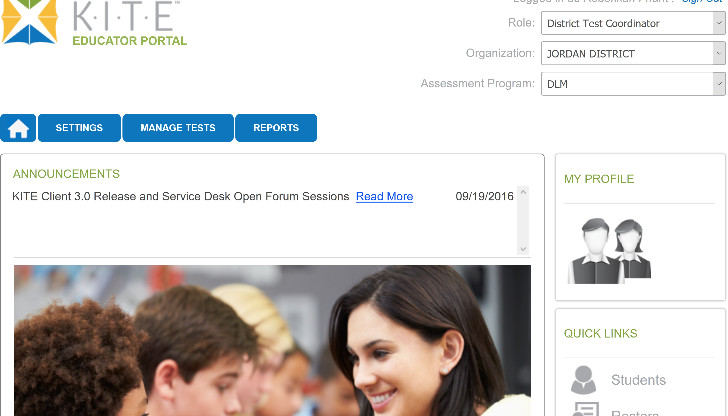

- Click Test Management 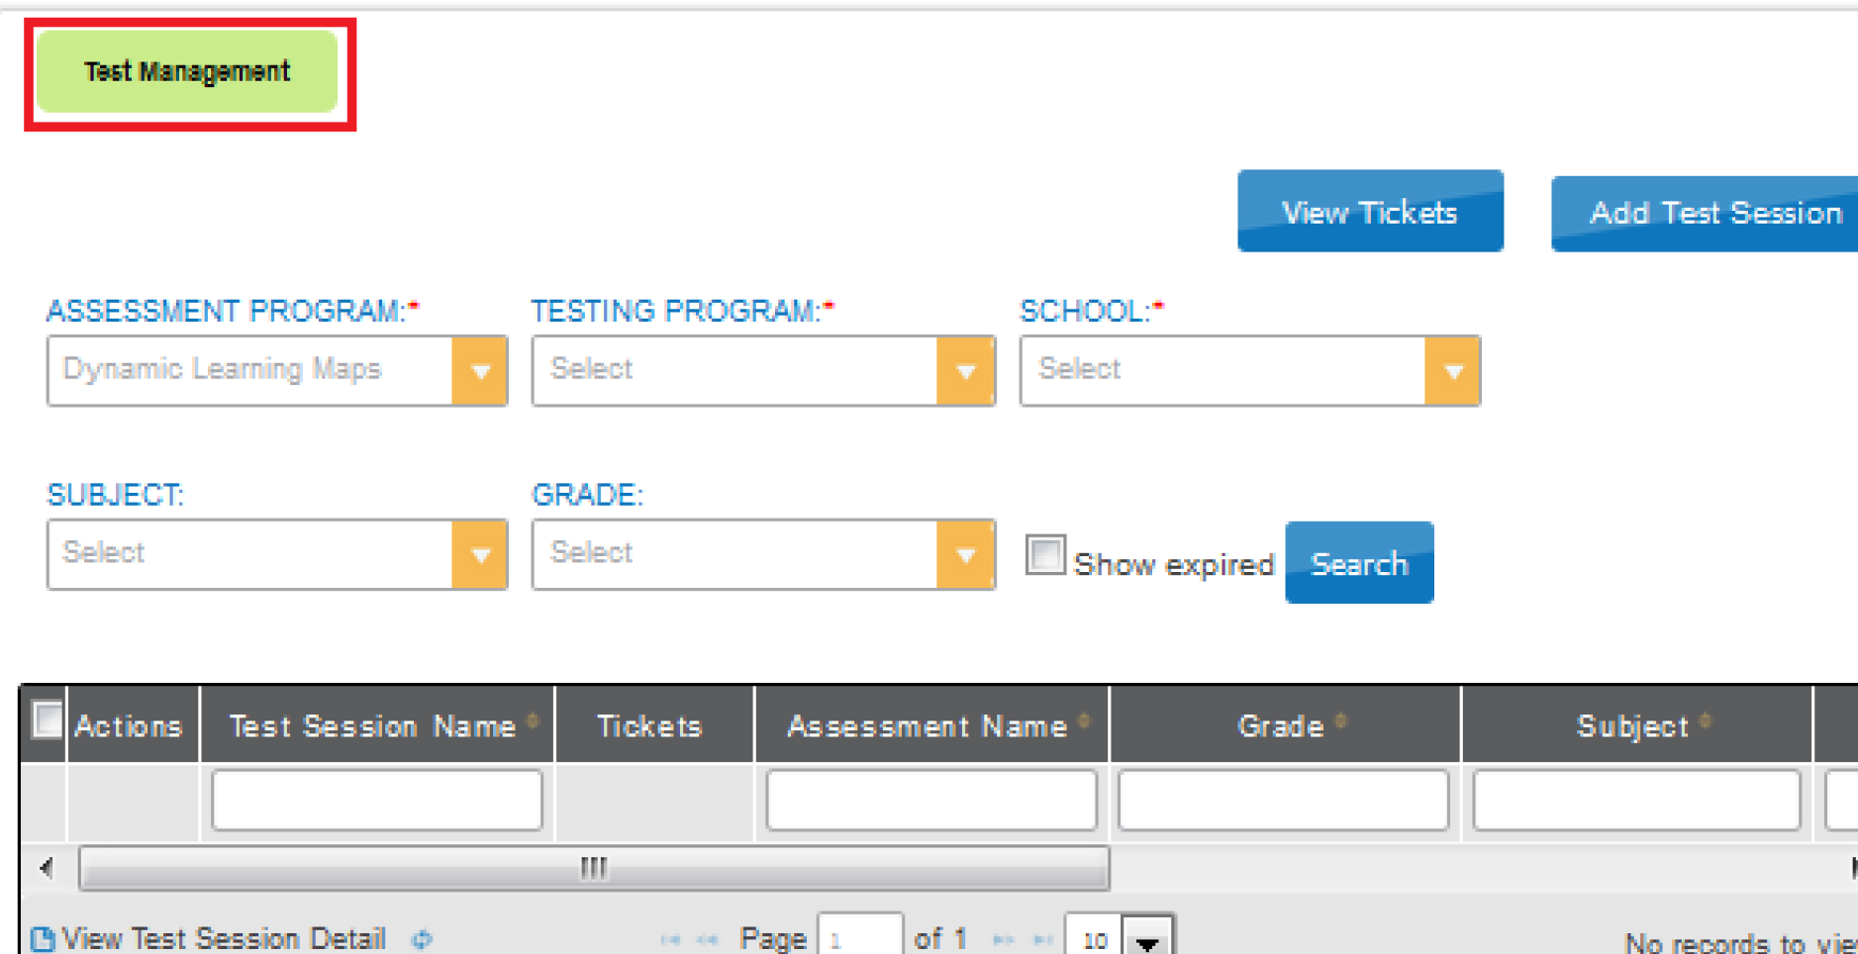

- If the Testing Program Box is not filled in, select Summative

- Click the PDF icon to view and print out the student’s username and password
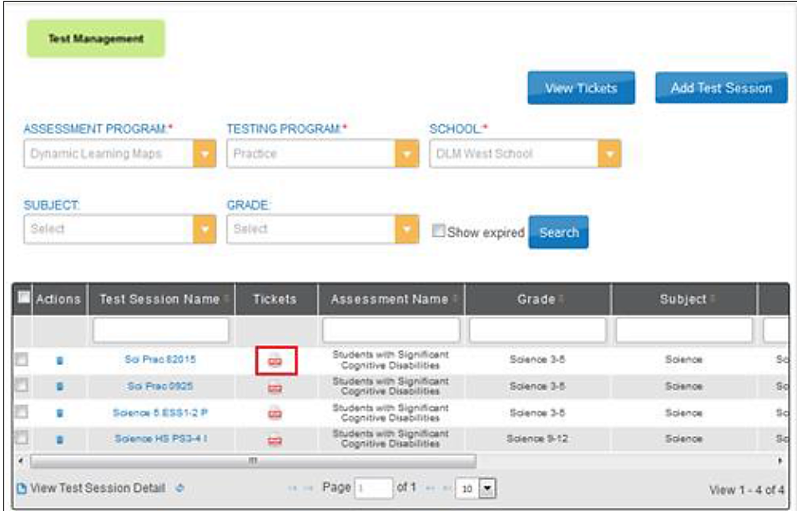
You can select up to 6 students to print out by clicking on box

- Click Open with
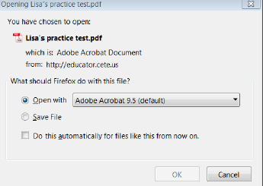

- Click OK

- Tickets will look similar to this:
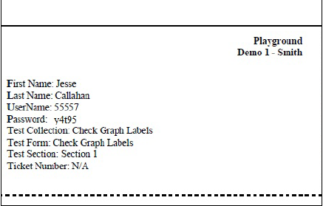
The student’s username and password will be the same for Math and Language Arts.

- Print the TIPS page for student (you will need to print a TIPS sheet for every testlet in each subject)

- Click Test Session Name
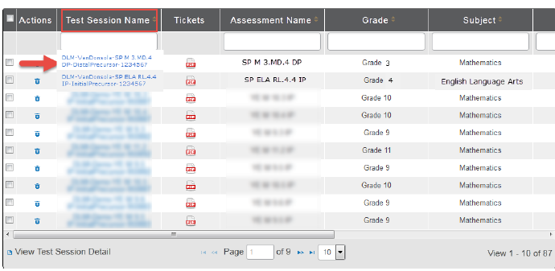
(Test Session names are long, look for the Student’s Last Name)

- Scroll over to the Test Information column and click PDF to view/open the TIP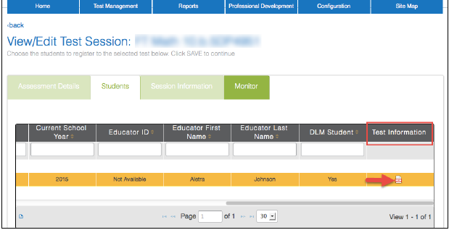

- Click Open with
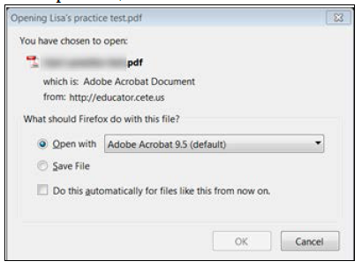
- View/Print the Testlet Information Page (TIP). When printing this document, remember that it is a SECURE Document. You may only want to print the pages that you need. (You only need to print out the alternate text passages if you are using Human Read Aloud)

- Gather Testing Materials listed on TIPS

- Click on Kite Client on student testing computer
- Enter the student’s Username and Password from the ticket you printed out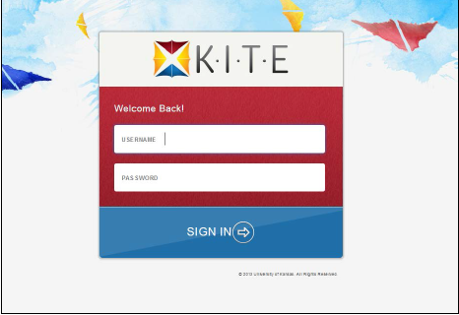
- Click Sign In

- Click Take a Test.

- Select Subject and Testlet; Click Take Test
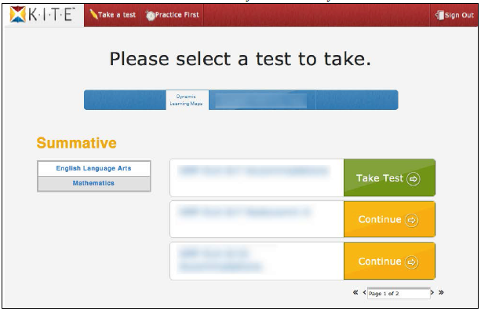
- Click Begin

- Students can break for up to 28 min during a testlet. After 28 min of no activity the system will bring up this message:
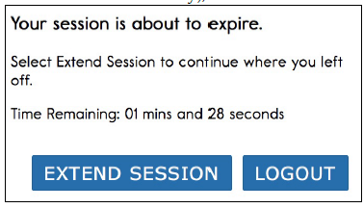

- If you need to end a testlet before a student is finished click on Exit Does not Save
- When student reaches end of testlet, you will see this:
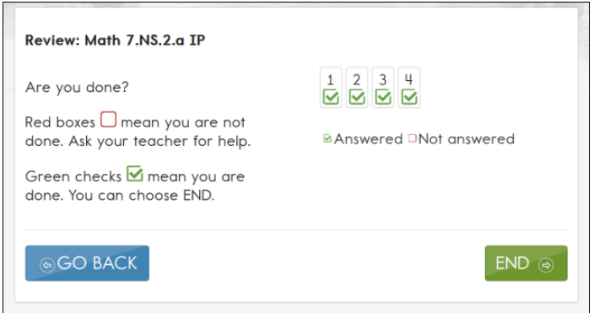
If you see green checks in every box, you can click End. If questions are unanswered click Go Back.

- After clicking End, click Yes
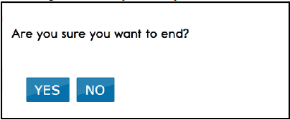
- Click Close Kite

- Follow Steps 7 thru 22 for each testlet in Math and English Language Arts. The number of testlets for each grade and subject are as follows:
