Jordan School District

SCRAM 102
Everything You Need to Know About Documenting IEP Services on SCRAM
Special Education Department
August 19, 2015

This training manual has been created to assist special educators in Jordan School District understand the importance of documenting IEP Services on SCRAM. It is also designed to explain how to complete the SCRAM document accurately and in a timely manner. If a special educator has questions or needs assistance, please contact the Teacher Specialist assigned to your school.

SCRAM 102
Everything You Need to Know
About Documenting IEP Services on SCRAM
Table of Contents
SECTION 1: FREQUENTLY ASKED QUESTIONS 2
1. Which comes first: the IEP services or the SCRAM document? 2
2. What is the correct procedure for SCRAM when a student’s IEP services change? 3
3. What is the correct procedure for SCRAM when an annual IEP is held and the services and minutes do not change? 5
4. What is SCRAM and why is it so important? 6
5. Why does the SCRAM document change, and which one is the most current? 8
6. When should SCRAM documents be submitted? 10
7. What key points must be considered when identifying services and minutes on the IEP and the corresponding SCRAM document? 13
8. What SCRAM circumstances are unique to students who are ages 3-5? 16
9. How important is the SCRAM caseload report/printout? 18
SECTION 2: ANATOMY OF A SCRAM DOCUMENT 22
- Student Demographic Data 23
- Entry Date 24
- IEP Services Section 25
- Disability Code 27
- Scram Time Service Pattern Code 28
- Environment Code 29
- Regular Percent 32
- Health Related Services 38
- Exit Date And Exit Code 40
RESOURCES (located at the end of the training manual)
IEP SCRAM Services Document (July 2013)
Jordan School District Weekly Minutes Calculator (Revised August 2014)
Health Related Services and/or School-Based Skills Development Services and Regular Percent
Reading the SCRAM Document

SCRAM 102
Everything You Need to Know
About Documenting IEP Services on SCRAM

SECTION 1: FREQUENTLY ASKED QUESTIONS

- Which comes first: the IEP services or the SCRAM document?

The IEP Services Always Come First! When developing an IEP, the Services section must accurately reflect the services that the student receives based on his/her IEP goals.

- Special Education Services are the services the student needs in order to achieve his/her annual goals and advance in the general curriculum.
- Related Services are the services the student requires in order to benefit from his/her special education.

As soon as the IEP is completed, an IEP SCRAM Services document (SCRAM document) must be completed and submitted to the SCRAM Secretary at the District Office (Preschool SCRAMs are submitted to the Jordan Child Development Center at Kauri Sue Hamilton School). The special education and related services and amount of time per day entered on the SCRAM document, must match the special education and related services and amount of time recorded in the services section of the IEP.

IEP
Special Education and Related Services
IEP SCRAM Services Document
(SCRAM)
IEP Special Education and Related Services must match the SCRAM document.

- What is the correct procedure for SCRAM when a student’s IEP services change?

In making changes to a student’s IEP after the annual IEP team meeting for a school year, the parent of a student with a disability and the LEA may agree not to convene an IEP meeting for the purposes of making those changes, and instead may develop a written document to amend or modify the student’s current IEP. (USBE SER III.I.2.a.)
Parents must be involved in any decision to amend the IEP services and must receive a copy of the revised IEP. After the amendment has been made to the IEP, the team exits the existing SCRAM document because it is no longer current, and then completes a new SCRAM document to reflect the new changes to the IEP. Each time an IEP is amended, this procedure is repeated. The exit and entry dates on the SCRAM documents must correlate with the date that changes were made on the IEP.

- SCRAM EXIT DATE: is the day AFTER the last day that the student received the services on the IEP.
- SCRAM ENTRY DATE: (of the new SCRAM document) is the first day that the new services start. As of July 2013, the new SCRAM ENTRY DATE is the same as the SCRAM EXIT DATE. Errors in exit and entry dates can result in a loss of days counted and loss of funding.
- Refer to Example 1: SCRAM Procedure when IEP Services Change

Example 1
SCRAM Procedure when IEP Services Change
Event | Date | Service | Minutes/Frequency | SCRAM
 |  |  |  | Entry Date | Exit Date
Annual IEP Meeting | 8/26/13 | Reading Comprehension | 45 minutes/day | 8/26/13 | 11/21/13  (*)
IEP Amended | 11/21/13  (*) | Reading Comprehension | 60 minutes/day  (minutes increased*) | 11/21/13  (*) | 4/9/14  (**)
IEP Amended | 4/9/14  (**) | Reading Comprehension | 60 minutes/day | 4/9/14  (**) | 8/20/14  (***)
 |  | Written Language** | 30 minutes/day  (service/minutes added**)
Annual IEP Meeting | 8/20/14  (***) | Reading Comprehension | 30 minutes/day  (minutes decreased***) | 8/20/14  (***)
 |  | Written Language | 45 minutes/day  (minutes increased***)

*  **  *** | Asterisks represent the sequence of changes in the IEP Services and SCRAM Entry/Exit Dates.

REMINDERS for SCRAM Procedures When a Student’s IEP Services Change!
- The original entry and exit SCRAM documents remain in the student’s special education file.
- Copies of both the exit and entry SCRAM documents are stapled and submitted to the SCRAM Secretary at the District Office to enter on the Skyward System.

- What is the correct procedure for SCRAM when an annual IEP is held and the services and minutes do not change?

If the annual IEP is held and there are no changes in services and minutes, an Exit and Entry SCRAM still need to be submitted immediately following the IEP meeting.

- SCRAM EXIT DATE: is the day AFTER the last day that the student received the services on the IEP.
- SCRAM ENTRY DATE: of the new SCRAM document is the first day that the new services start. As of July 2013, the new SCRAM ENTRY DATE is the same as the SCRAM EXIT DATE. Errors in exit and entry dates can result in a loss of days counted and loss of funding.
- Refer to Example 2: SCRAM Procedure when Annual IEP & Services/Minutes do not Change

EXAMPLE 2
SCRAM Procedure when Annual IEP & Services/Minutes do not Change
Event | Date | Service | Minutes/Frequency | SCRAM
 |  |  |  | Entry Date | Exit Date
Annual IEP Meeting | 8/26/13 | Reading Comprehension | 45 minutes/day | 8/26/13 | 8/25/14*
Annual IEP Meeting | 8/25/14* | Reading Comprehension | 45 minutes/day | 8/25/14*

(*) Asterisk represents the sequence of changes in the IEP Services and SCRAM Entry/Exit Dates.
REMINDERS for Changing Entry and Exit Dates on SCRAM Documents!
- Original entry and exit SCRAM documents remain in the student’s special education file.
- Copies of both the exit and entry SCRAM documents are stapled and submitted to the SCRAM Secretary at the District Office to enter on the Skyward System.

- What is SCRAM and why is it so important?
State and Federal Requirements:
SCRAM stands for Self-Contained and Resource Accounting Management and documents the services that are listed on each student’s IEP. SCRAM is used to collect special education information to determine State special education funding for the LEA, and to facilitate required Federal reporting. We are required to account for our special education students 3 times per year:
- October 1st
- December 1st
- End of School Year (exit counts are needed to calculate daily average membership)

SCRAM Memos:
District-level due dates help us meet the required timelines for reporting SCRAM, and are scheduled in advance of the October 1st, December 1st, and end of year deadlines to allow sufficient time for data entry of 5000+ student documents. These due dates and instructions are sent via Intradistrict Communication (memos) to all principals, special educators, and related service providers PRIOR to the due dates. It is very important to read and follow the instructions in these memos and submit the required information by the due dates.

SCRAM Secretary:
The SCRAM Secretary in the Special Education Department enters all SCRAM data on the Skyward System. Her position is a data entry position; she does not have a background in Special Education, does not interpret data, cannot second-guess errors or incomplete SCRAM documents, and therefore, must receive accurate and complete SCRAM documents to streamline the data entry process. Submitting accurate SCRAM information is critical for her to be able to enter the data by the required reporting timelines.

Consequences (Positive & Negative):
Our SCRAM counts generate numbers for funding allocations such as staff (teachers, paraeducators, SLPs, support staff), student needs (transportation, medical, etc.), special programs (self-contained support classes, special schools, etc.), instructional materials and curriculum, and technology, etc. If a student receives special education and/or related services without a current SCRAM record on Skyward, that student’s data is not included in the numbers reported to the Utah State Office of Education. If a student has a current SCRAM record on Skyward and is not receiving special education and related services, the student is counted inappropriately and the District would be required to give back funding. Special education funding is contingent upon the accuracy of the SCRAM data.

REMINDERS for Completing and Submitting SCRAM Data on Time!
- Address the SCRAM memos, immediately.
- Submit all SCRAM information by the due dates outlined in the SCRAM memos.
- Complete the SCRAM documents accurately and completely, to ensure that the data are entered on the Skyward System within the required timelines.

- Why does the SCRAM document change, and which one is the most current?
Revisions to our SCRAM document reflect changes in Federal and State requirements. The most current SCRAM document contains all of the required data fields that must be reported. Use the “Revised November 2014” IEP SCRAM Services document.
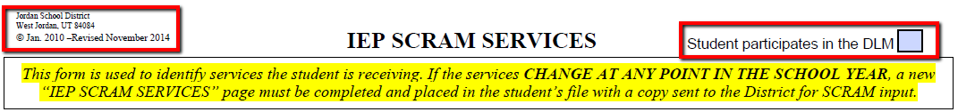
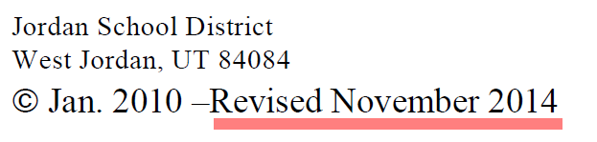

Intradistrict Communication, November 19, 2014: DLM Flag on Skyward
The Dynamic Learning Map (DLM) is the new State assessment for students with significant cognitive disabilities. The DLM replaces the UAA for Language Arts and Math. In order for the student information to upload into the Utah Office of Education UTREX system, a flag was created within Skyward. This has necessitated the need to make a change to the SCRAM document. On the upper right-hand side of the SCRAM document, the statement, “Student participates in the DLM has been added. If the IEP team has determined that the student will take the DLM assessment, then this box should be checked. If the student will take the SAGE, then this box will not be checked. It is imperative that when SCRAM documents are completed, that the special educator completing the document marks the DLM box for students who are designated to the take the DLM, so this information is entered into the Skyward System and can roll into the UTREX system.

REMINDERS for Using the Current SCRAM Document!
- Use the “Revised November 2014” IEP SCRAM Services document.
- A template of the IEP SCRAM Services (Revised July 2013) form is posted on the Special Education Web site (Forms > SCRAM).
- The original entry and exit SCRAM documents remain in the student’s special education file.
- Copies of both the exit and entry SCRAM documents are stapled and submitted to the SCRAM Secretary at the District Office to enter on the Skyward System.

- When should SCRAM documents be submitted?
Data collection and maintaining SCRAM counts are ongoing processes all year long. If the student’s IEP services change at any point in the school year, submit the appropriate exit and entry SCRAM documents to reflect the changes to the IEP services (follow the steps outlined in Question 2. What is the correct SCRAM procedure when a student’s IEP services change?). SCRAM documents must be submitted when IEP services change and/or at the following times:
- Typical school transition periods:
- Preschool to Kindergarten
- Elementary to Middle School (6th grade to 7th grade)
- Middle School to High School (9th grade to 10 grade)
- High School to Post-High School (12th grade to graduation, 12th grade to South Valley School)
- Changes to a student’s IEP, classification, placement, enrollment:
- When an initial IEP is completed.
- When an annual IEP is completed.
- When IEP services change (increase or decrease in time and/or service).
- When a student comes from another school and enters your setting during the year.
- When a student leaves your school.
- When a student is no longer eligible for special education.
- When a student’s classification changes.
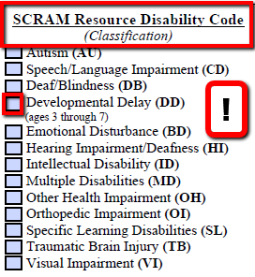
REMINDERS!
Students classified as Developmentally Delayed (DD) must be reclassified PRIOR to their 8th birthday (regardless of the 3 year re-evaluation due date).

Students who maintain a DD classification after their 8th birthday cannot be submitted for funding.

- When a student’s service pattern changes:
From | To
Resource (A or B) | Resource Self-Contained (C)
Resource Self-Contained (C) | Resource (A or B)
Resource Self-Contained (C) | Self-Contained Support Class (G)
Self-Contained Support Class (G) | Resource A, B, C, Special School (E)
Special School (E) | Resource A, B, C, or Self-Contained Support Class (G)
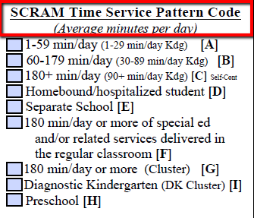

  - When a student’s Environment Code changes:
From | To
Early Childhood (Ages 3-5) | School Age (Ages 6-21)
Regular School Setting (V) | Any other setting, or reverse
Public Separate School (S) | Any other setting, or reverse
Regular (V)  or Separate School (S) | *Homebound/Hospitalized (H), or reverse
*Clarification of Students Served on Home/Hospital (H)
Short Term Injury or Illness
This is not a change in placement, nor is it a change in environment code. It is an adjustment of service. Under these circumstances, DO NOT exit the student’s SCRAM.
Long-Term Injury or Illness
The student is homebound. This is a change in placement and environment code. Hold an IEP meeting to determinate what the appropriate service at home in order for the student to receive FAPE. Document the change of IEP services on the IEP and the student’s placement. Complete a Change of Placement and submit a new SCRAM to reflect the IEP change in IEP services.
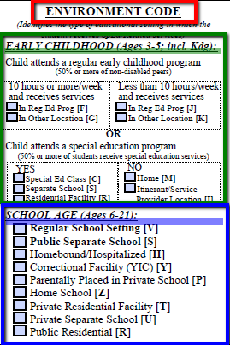

REMINDERS Regarding Environment Codes!
- Consultation with the Jordan School District Director of Special Education is required for the following Environment Codes:
- (Y) Correctional Facility
- (T) Private Residential Facility
- (U) Private Separate School
- (R) Public Residential
- Consultation with the Special Education Administrator working with Private and Home Schools, is required for the following Environment Codes:
- (P) Parentally Placed in Private School
- (Z) Home School

- What key points must be considered when identifying services and minutes on the IEP and corresponding SCRAM document?

Special education is specially-designed instruction. Specially-designed instruction means adapting, as appropriate to the needs of an eligible student under these Rules, the content, methodology, or delivery of instruction in order to:
- Address the unique needs of the student that result from the student’s disability.
- Ensure access of the student to the general curriculum, so that he or she can meet the educational standards within the jurisdiction of the LEA that apply to all students. (USBE SER I.E.39)

All IEP service minutes are individualized and determined by the IEP team (not by a program or a specific location). IEP service times/minutes must only include time when a student is in school and specialized instruction is being provided. Teams CANNOT count time when specialized instruction is not occurring (e.g., Friday short days, middle and high school collaboration time, release time, etc.).

- Consultation: Consultation is an indirect service for a student that usually occurs between a student’s teachers, staff, and parents, and therefore, IS NOT an IEP service and cannot be counted as IEP service time.

- Monitoring: Monitoring may be counted as an IEP service pattern ONLY if specially designed instruction is being provided by a certified special educator (specially designed instruction requires that we are adapting the content, methodology or delivery of instruction for a given student). If the student does not need specially designed instruction, they are not eligible for special education services.
- Note: Checking grades, checking attendance, monitoring homework completion, etc., is not specially designed instruction. These activities should be done with all students (including at-risk students); they are not special education issues and would not be considered specialized instruction.
- Specially designed instruction (or specialized instruction) requires that you are doing something different from what is done with every general education student.
- If the specified criteria are met to claim “monitoring” as an IEP service for a given student, the following requirements must be met:
- The IEP team must have data to document the delivery of monitoring as a special education service; the team must be able to show how they are delivering “specialized instruction.”
- Monitoring services are only appropriate if provided for a limited period of time as a way to transition a student out of services or to a less restrictive service pattern.
- Note: Counting students who are being inappropriately “monitored” could result in a loss of funds for the district. As a result, high “monitoring” numbers in a school will be flagged for a compliance review.

- Mainstream and Inclusion: If a student is mainstreamed and the time is being counted as service minutes, the team must be able to justify that specialized instruction is being provided (i.e., classroom assistance, prompting, redirecting, behavior corrections, etc.).

- Self-Contained Support Classes and Special Schools: If the IEP team has determined that lunch, recess, and breaks are to be counted as instructional time, there must be documentation that support these periods as instructional time. It is recommended that the IEP team document the decision to count lunches, recesses, and breaks as instructional time in Section 7 of the GoalView IEP (i.e., The IEP team has determined that the student will receive adaptive P.E. and specialized instruction during lunch, recess, and breaks).

- Co-teaching: Co-teaching is an optional service delivery model, and should not be the only option for students with disabilities to access the general curriculum. The IEP must consider the degree of specialized instruction the student needs in order to meet his/her IEP goals. The amount of time that should be counted for the IEP service depends on the needs of the student and how the special education teacher delivers the service on a regular basis.
- Only the amount of time that is spent delivering specially designed instruction (adapting the content, methodology, or delivery of instruction) may be counted as special education.
- Providing accommodations is not considered specially designed instruction (Co-Teaching Handbook, Utah Guidelines, Utah State Office of Education, September 2011).

- What SCRAM circumstances are unique to students who are ages 3-5?
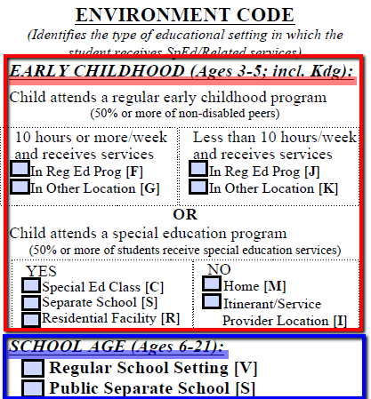
- Early Childhood Environment Codes: All students who are age 3-5 must be reported using Early Childhood Environment Codes. This includes kindergarten students who are age 5.

When the student turns 6 years old, the team must exit the student from the Early Childhood Environment Code and re-enter the student using a School-Age (6-21) special education environment code.

REMINDERS!
- This is a change in environment code, not a change in placement. An IEP meeting is not required.
- If the early childhood environment code is not used for all 5 year-olds (including those in kindergarten) or the environment code is not changed to a school-age code once the student turns 6 years old, the student’s SCRAM record will not be submitted to the State and the District will lose funding for that student.

- One of the following Early Childhood Environment Codes must be selected on the SCRAM document, based on the setting in which the student receives special education and related services:

- Child attends a regular early childhood program comprised of 50% or more nondisabled peers, for 10 hours or more per week.
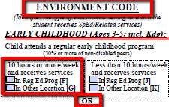
  - Code F: Child receives special education and related services in the regular education program (i.e., Headstart Preschool class, or a 5 year old in a regular Kindergarten class).
  - Code G: Child receives special education and related services in some other location (i.e., child attends a private preschool in the community and receives IEP services in a special education preschool class).

- Child attends a special education program that consists of 50% or more of students receiving special education.
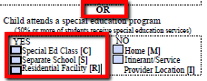
- Code C: Child attends a special education class (i.e., Preschool class, or is a 5 year-old in a Diagnostic Kindergarten class).
- Code S: Child attends a special education class in a separate school (i.e. a 5 year-old in a Kindergarten class at Kauri Sue Hamilton School).
- Code R: An IEP team decision is made to provide special education and related services in a residential facility (i.e., care center).

- Child receives special education and related services in other location.
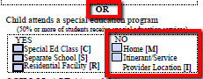
- Code I: Child receives special education and related services in a service provider location (i.e., Itinerant SLP services in an elementary school location).
- Code M: An IEP team decision is made to provide special education and related services in the child’s home.

- How important is the SCRAM caseload report/printout?

The information from each individual SCRAM document is represented on the school’s SCRAM Caseload Report, and comprises the data that are submitted to the State. The caseload report is sent with an accompanying SCRAM memo to special education team leaders PRIOR to the October 1st, December 1st, and end of year reporting periods. All team members and service providers need to verify each student on the list as correct, changed, deleted, and/or incomplete. Detailed instructions are included in the memo for checking the caseload report (refer to Reading the SCRAM Report in the Resources section of this training manual).

Sections of the SCRAM Caseload Report/Printout:

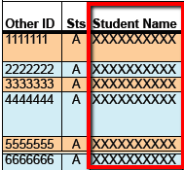
- Every student receiving services must be listed on the report.
- If a student is receiving services, but his//her name is not listed on the report, submit an entry SCRAM document.
- If a student is listed on the report, but s/he is no longer enrolled at your school, submit an exit SCRAM document.

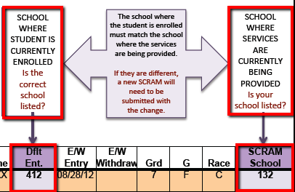
- Each student’s Default and SCRAM school numbers must match.
- Default School is the school where the student is currently enrolled.
- SCRAM School is the school where services are currently being provided to the student.
- If they are different, submit a new entry SCRAM document with the change.

- SCRAM Entry/Exit Dates and Exit Codes
All SCRAM services are entered with an entry date and exited with an exit date and code. These dates will be reflected on the SCRAM report throughout the year as services change and IEPs are held.

- SCRAM Entry Date:
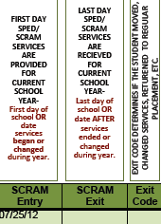
- The entry date is either the first day of school OR the first day the services listed on the SCRAM were provided.
- If the services are updated or changed during the year, they must be re-entered with a new entry date on a new SCRAM.
- If the services are updated or changed during the year, the
- new SCRAM entry date will be the same as the exit date.

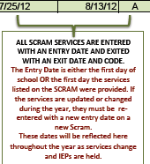
- SCRAM Exit Date:
- The exit date is the day AFTER the last day the student received the services listed on the SCRAM document.
- An exit date must be listed if the student is being exited from existing services; either for changes or to discontinue services completely.

- Exit Code:
- The exit code determines if the student moved, changed services, returned to regular placement, etc.
- Every exit date must have an exit code.
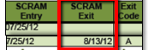
- Please note: If a student exits services any time throughout the year, his/her name will remain on the report. If a SCRAM Exit date is listed, please do not send in another exit SCRAM document.

- All of the following information from the SCRAM document must be correct. A new SCRAM document needs to be submitted to change the information in these sections.

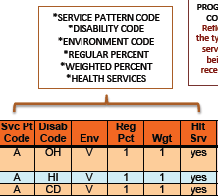
- Service Pattern Code: This is the amount of time per day, in minutes that the student receives special education and related services. Minutes of specialized instruction and related services are counted when delivered in the general education classroom, in a special education classroom, or in other settings.
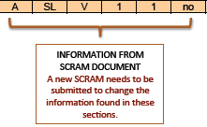
- Disability Code: This identifies the type of disability under which the student has been determined eligible for special education and related services.

- Environment: This is the type of educational setting in which the student receives special education and related services.
- Ages 3-5, use an Early Education Environment Code
- Ages 6-21, use a School-Age Environment Code
- V: Regular School Setting
- S: Public Separate School
- H: Homebound/Hospitalized

- Regular Percent: This is the amount of time the student receives education in a regular education classroom with nondisabled peers during the day.
- 1 = At least 80% of the school
- 2 = 40-79% of the school
- 3 = Less than 40% of the school day

- Health Services: If the student receives IEP health related services during the school day (i.e., speech, guidance, occupational therapy, adaptive EP, etc.), this column should be marked “Yes.”
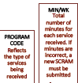
- Program Service Code and Minutes per Week
Services and minutes listed on the SCRAM report must reflect the services and minutes listed on the student’s IEP.
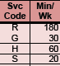
- The program services code represents the type of services the student receives.
- If the IEP services have changed, submit exit and new entry SCRAM documents to reflect the correct information.
- Minutes per Week are the total number of minutes for each service that the student receives. If the IEP minutes for any service are incorrect, submit exit and new entry SCRAM documents to reflect the correct information.

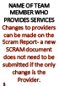
- Provider: The provider is the name of the team member who provides the services. Changes to providers can be made on the SCRAM report; a new SCRAM document does not need to be submitted if the only change is the Provider.

SECTION 2: ANATOMY OF A SCRAM DOCUMENT
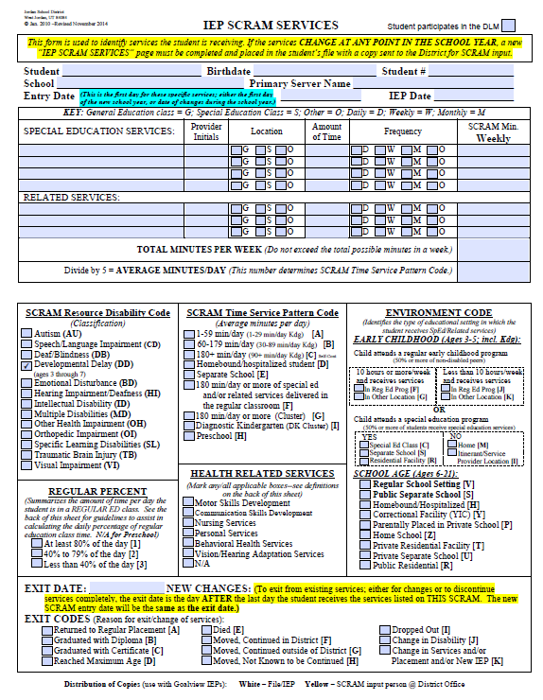
3. IEP Services
2. Entry Date
1. Student Demographic Data
7. Regular Percent
9. Exit Date and Exit Code

8. Health Related Services
5. SCRAM Time Service Pattern Code
6. Environment Code
4. Disability Code

1. Student Demographic Data
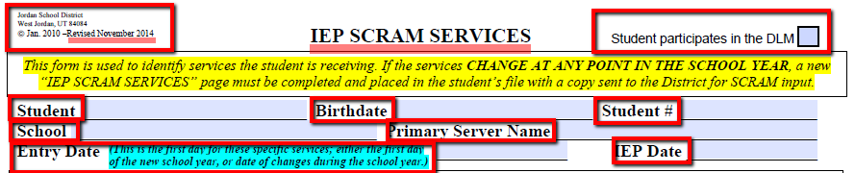

Guidelines for Completing Student Demographic Data
- All information must be accurate and complete.
- Use the current SCRAM Document: Revised November 2014 IEP SCRAM Services.
- See Resources for copy of current SCRAM document.
- Template form is posted on the Special Education Website (Forms > SCRAM).

Common Errors for Student Demographic Data:
- Student name does not match student number.
- Student number is left blank.
- Date of Birth is blank or wrong date for student.
- IEP Date is left blank. (Note: SCRAM documents correspond to the date of the IEP.)
- An outdated version of the Scram form is used.
- Student’s SCRAM school does not match the school where the student is enrolled.

2. Entry Date
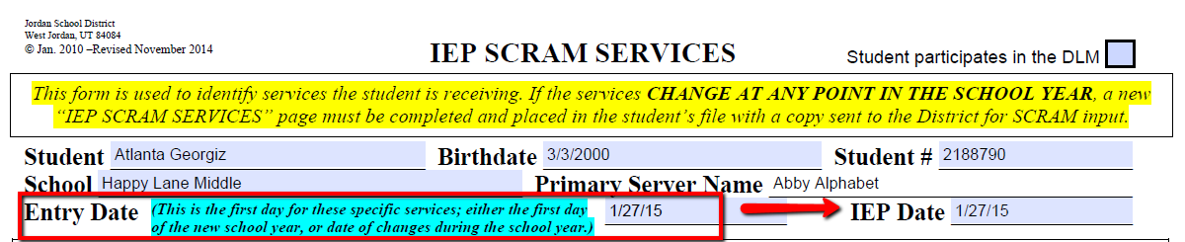
Guidelines for Completing the Entry Date
- The Entry Date is the first day for the specific services listed; either the first day of the new school year, or the date of changes during the school year.
- When a student’s IEP services change, the new SCRAM entry date will be the same as the exit date.

Common Errors for Entry Date:
  - The entry date is not changed to reflect the date of the changes on the IEP.
  - The entry date is left blank.
  - A new IEP is held, but the entry date does not change to reflect the new IEP date.
  - Errors in entry (and exit dates) can result in a loss of days counted and loss of funding

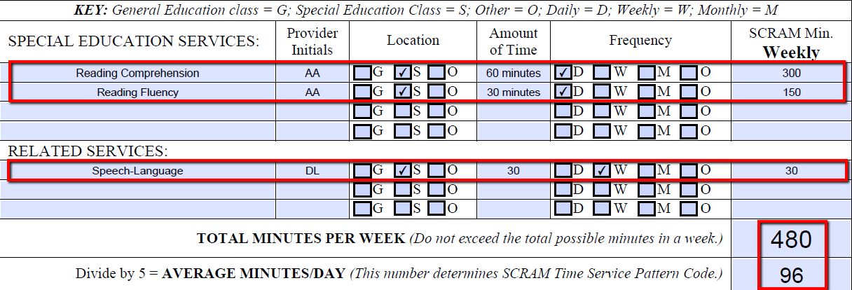
3. IEP Services
Guidelines for Completing the IEP Services
- The services and minutes listed on the SCRAM document must reflect the services and minutes listed on the IEP.
- List each special education service by content area (i.e. reading, math, writing, etc.). Also list:
- The service provider’s initials,
- The amount of time for each service,
- The frequency of delivery for each service, and
- The location where each service will be delivered.
- List each related service with the initials of the corresponding service provider; the amount of time, frequency and location of services. Also list:
- The service provider’s initials,
- The amount of time for each service,
- The frequency of delivery for each service, and
- The location where each service will be delivered.
- If Speech or Guidance is the only service, it is a special education service (not a related service).
- Enter the correct minutes in the “Weekly” column. (Note: If a service is provided monthly, it must be calculated correctly in the Weekly column).
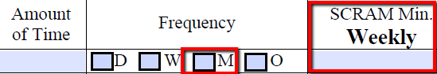
Common Errors for IEP Services:
- Specialized instruction is listed as broad, general areas, instead of specific content areas (special education, resource, cluster, etc. are not content areas).
- A SCRAM document is submitted without all of the special education and related services listed.
- Amount of time and frequency listed for a service do not match SCRAM minutes weekly.
- Consultation is listed as a special education or related service.
- Monitoring is listed as specialized instruction over an extended period of time.
- Average minutes per day exceed the total minutes of the school day (use the Jordan School District Weekly Minutes Calculator, Revised August 2013 in the Resources section of this training manual).

4. Disability Code

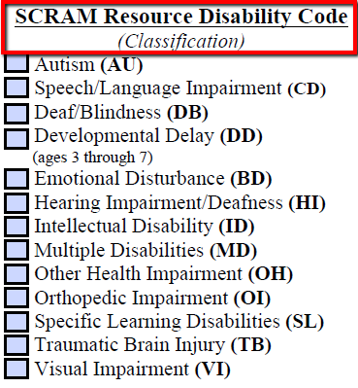

Guidelines for Completing the Disability Code
- Mark only one Disability Code (the student’s disability is listed on the Determination of Eligibility form).
- Developmental Delay (DD): Students classified as DD must be reclassified prior to their 8th birthday (regardless of the 3 year re-evaluation due date). Students, who maintain a DD classification after their 8th birthday, cannot be submitted for funding.

Common Errors for Disability Code:
  - The disability code is left blank.
  - More than one disability code is marked.
  - The DD disability code does not match the age of the student.

5. SCRAM Time Service Pattern Code

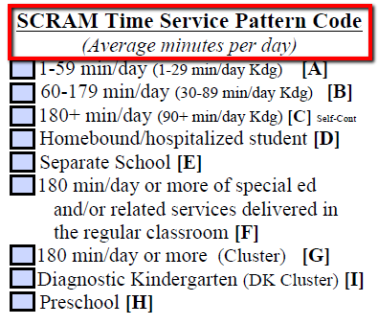

Guidelines for Completing the Scram Time Service Pattern Code
- The SCRAM time service pattern code correlates with the total average minutes per day.
- Preschool (H) is marked for any preschool student, regardless of the average minutes per day.
- Code “F” is marked if the student is self-contained and receives most of his/her services in the regular classroom (i.e., a student with muscular dystrophy who has been assigned a paraeducator to assist in all settings).
- Mark only one service pattern code.

Common Errors for SCRAM Time Service Pattern Code:
  - No code is marked.
  - More than one code is marked.
  - Code “F” is marked instead of “C” (Resource self-contained) or “G” (Self-contained support class – cluster).
  - Student is receiving services while on Home/Hospital, but Code D is not marked.

6. Environment Code
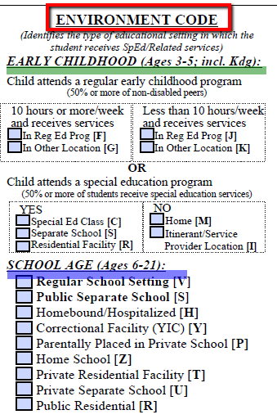

The Environment Code refers to the type of educational setting in which the student receives special education and related services.

There are 2 major categories for reporting the Environment Code:

1. EARLY CHILDHOOD (Ages 3-5)

2. SCHOOL AGE (Ages 6-21)

Guidelines for Completing the EARLY CHILDHOOD (Ages 3-5) Environment Code
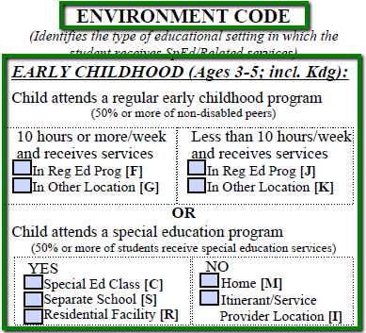
- Use the Early Childhood codes for all students who are ages 3-5, including Kindergarten students who are age 5.
- When the student turns 6 years old, teams must exit the student from the Early Childhood Environment Code and re-enter the student using a School-Age (6-21) special education environment code.
- This is a change in environment code, not a change in services or placement. An IEP meeting is not required.
- If the early childhood environment code is not used for all 5 year-olds (including those in kindergarten), or the environment code is not changed to a school-age code once the student turns 6 years old, the student’s SCRAM record will not be submitted to the State, and the District will lose funding for that student.
Use the following codes for 5-year old students in Kindergarten:
Early Childhood (3-5) Setting  5-Year Old Student in Kindergarten | Code
Regular Kindergarten Class | F
Diagnostic Kindergarten Class | C
Kindergarten class at Kauri Sue Hamilton School | S

Guidelines for Completing the SCHOOL AGE (Ages 6-21) Environment Code
Use the following School Age codes for students who are ages 6-21:
School Age (6-21) Setting | Code | 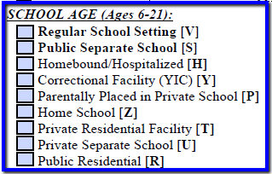
Regular School Setting  (Elementary, Middle & High Schools) | V
Public Separate School  (Center-based Schools) | S
Homebound/Hospitalized  (Students on Home/Hospital) | H
Parentally Placed in Private School* | P*
Home School* | Z* | *Consultation with the Special Education Administrator working with Private and Home Schools is required.  ** Consultation with the Jordan School District Director of Special Education is required.
Correctional Facility (YIC)** | Y**
Private Residential Facility** | T**
Private Separate School** | U**
Public Residential** | R**

Common Errors for Environment Code:
- A code is not marked.
- A Kindergarten student age 5 is reported with a School Age code.
- A Kindergarten student age 5 turns 6, but the Early Childhood code is not changed to School Age.
- Student on Home/Hospital is marked with code V or S, instead of code H.

7. Regular Percent
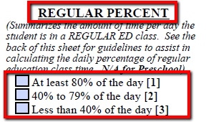

The following graphic is located on page 2 of the IEP SCRAM Services document (see Resources, page …
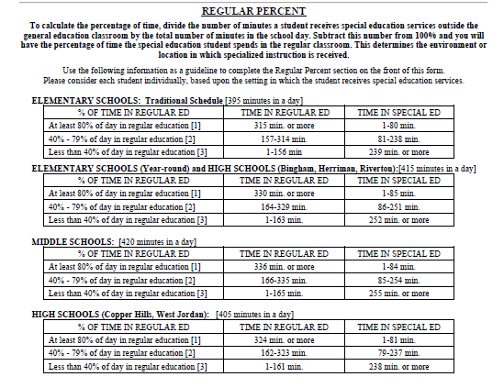

Guidelines for Completing Regular Percent
- Regular percent is the amount of time the student receives education in a regular education environment with nondisabled peers during the school day.
- Regular percent refers to where the student is (physical location), not who is delivering the instruction (refer to Regular Percent: Examples 1-5).
- Regular percent is not the same as service time.
- If a student is enrolled in a self-contained support class and is mainstreamed to a regular education class during the day, the regular percent must reflect the percent of time with nondisabled peers.
- If a student is enrolled in a special school and is mainstreamed to a regular school or participates in a community-based training experience during the day, the regular percent must reflect the percentage of time with nondisabled peers.
- Regular percent does not apply to students ages 3-5.
- Consider each student individually, based on the setting in which the student receives special education services.
- Use the Regular Percent Table in the Resources section of this training manual, to calculate the daily percentage of regular education class time for your school/setting.

Common Errors for Regular Percent:
  - Regular percent is not marked.
  - The wrong percent is marked (remember, “regular percent” is not the same as the SCRAM Time Service Pattern Code).
  - For students in special schools or self-contained support classes who are mainstreamed or served in community-based settings, the regular percent code must reflect the time spent with non-disabled peers in those setting (e.g., if a student spends ½ the day in mainstream or in a community-based site with non-disabled peers, the regular percent code should be “40% to 79% of the day” or level 2). It should NOT be the same as the service time, or time the student is assigned to the self-contained support class (i.e., 180 or more minutes).

Example 1

IEP for K-12 Student
TIME | REGULAR PERCENT* | ENVIRONMENT
A = 1-59 minutes of special education services per day | 1 = at least 80% of day in regular education | V = regular school
Reading Fluency:  Minutes of special education services in special education classroom per day = 30  Total minutes of special education services per day = 30 | Total day = 6 hours (360 minutes)  Minutes in regular education per day = 360 – 30 (in special education room) = 330  330/360 = 92% | Team placed student in regular education with resource services.

Special Education Services:
- Reading Fluency S (special education classroom) 30 min., 5x/week

*Example is based on a six-hour day, including lunch and recess (breaks).

Example 2

IEP for K-12 Student
TIME | REGULAR PERCENT* | ENVIRONMENT
B = 40-179 minutes of special education services per day | 1 = at least 80% of day in regular education | V = regular school
Reading Fluency:  Minutes in special education per day = 30 min., 5x/week  Reading Comprehension: Minutes of special education services in regular education per day = 30 min., 5x/week  Total minutes of special education services per day = 60 | Total day = 6 hours (360 minutes)  Minutes in regular education per day = 360 – 30 = 330  330/360 = 92% | Team placed student in regular education with resource services.

Special Education Services:
- Reading Fluency S (special education classroom) 30 min., 5x/week
- Reading Comprehension G (regular education classroom) 30 min., 5x/week

*Example is based on a six-hour day, including lunch and recess (breaks).

Example 3

IEP for K-12 Student
TIME | REGULAR PERCENT* | ENVIRONMENT
C = 180+ minutes of special education services per day | 2 = 40% to 70% of the day in regular education | V = regular school
Reading Fluency:  Minutes in special education per day = 60 min., 5x/week  Reading Comprehension:  Minutes of special education services in regular education per day = 30 min., 5x/week  Math Calculation:  Minutes in special education per day = 30 min., 5x/week  Math Reasoning:  Minutes in special education per day = 30 min., 5x/week  Written Language:  Minutes in special education per day = 60 min., 5x/week  Total minutes of special education services per day = 210 | Total day = 6 hours (360 minutes)  Minutes in regular education per day = 360 – 180 = 180  180/360 = 50% | Team placed student in regular education with resource services.

Special Education Services:
- Reading Fluency S (special education classroom) 60 min., 5x/week
- Reading Comprehension G (regular education classroom) 30 min., 5x/week
- Math Calculation S (special education classroom) 30 min., 5x/week
- Math Reasoning S (special education classroom) 30 min., 5x/week
- Written Language S (special education classroom) 60 min., 5x/week

*Example is based on a six-hour day, including lunch and recess (breaks).

Example 4

IEP for K-12 Student
TIME | REGULAR PERCENT* | ENVIRONMENT
C = 180+ minutes of special education services per day | 1 = at least 80% of day in regular education | V = regular school
Reading Fluency:  Minutes in special education per day = 60 min., 5x/week  Reading Comprehension:  Minutes of special education services in regular education per day = 30 min., 5x/week  Math Calculation:  Minutes in special education services in regular education per day = 30 min., 5x/week  Math Reasoning:  Minutes in special education services in regular education per day = 30 min., 5x/week  Written Language:  Minutes in special education services in regular education per day = 60 min., 5x/week  Total minutes of special education services per day = 210 | Total day = 6 hours (360 minutes)  Minutes in regular education per day = 360 – 60 = 300  300/360 = 83% | Team placed student in regular education with resource services.

Special Education Services:
- Reading Fluency S (special education classroom) 60 min., 5x/week
- Reading Comprehension G (regular education classroom) 30 min., 5x/week
- Math Calculation G (regular education classroom) 30 min., 5x/week
- Math Reasoning G (regular education classroom) 30 min., 5x/week
- Written Language G (regular education classroom) 60 min., 5x/week

*Example is based on a six-hour day, including lunch and recess (breaks).

Example 5

IEP for School to Post-School Transition Student
TIME | REGULAR PERCENT* | ENVIRONMENT
E = Separate School 180+ minutes of special education services per day | 1 = at least 80% of day in regular education | S = Public Separate School
Work-Related Skills  Minutes in special education per day = 30 min., 5x/week  Functional Reading:  Minutes in special education per day = 30 min., 5x/week  Community-Based Job Training:  Minutes in special education services in regular education (community-based) per day = 300 min., 5x/week  Total minutes of special education services per day = 360 | Total day = 6 hours (360 minutes)  Minutes in regular education (community-based) per day = 360 – 60 = 300  270/360 = 83% | Transition program is directed from a separate public post-high school setting.

Special Education Services:
- Work-Related Skills S (special education classroom) 30 min., 5x/week
- Functional Reading S (special education classroom) 30 min., 5x/week
- Community-Based Job Training G (community) 300 min., 5x/week

*Example is based on a six-hour day, including lunch and recess (breaks).

8. Health Related Services
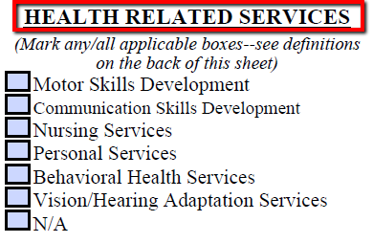

The following chart for Health Related Services is located on page 2 of the IEP SCRAM Services document (refer to Resources, page …)
Health Related Services and/or School-Based Skills Development Services
The following are definitions for the Health Related Services.
Please remember that you must have documentation that these services are being delivered.
- Motor Skills Development designed to enhance a student’s fine and gross motor skills including muscle coordination and strength, ambulation, range of motion, grasp and release and oral motor functioning. This service would take place under the supervision of an occupational therapist or a physical therapist.
- Communication Skills Development designed to enhance a student’s ability to communicate through the development of functional expressive speech or sign language, functional use of adaptive equipment and devices or improved oral-motor functioning. This service would take place under the supervision of a speech-language pathologist.
- Nursing Services designated to enhance or maintain a student’s health status including such services as medication administration, seizure control, treatment and repositioning to maintain skin integrity, tube feeding, catheterization and weight management.
- Behavioral Health Services designed to mitigate behaviors such as aggression, self-abuse, property destruction, severe non-compliance or withdrawal when those behaviors significantly impact a student’s ability to benefit from special education.
- Vision and Hearing Adaptation Services (necessitated by a student’s absence or loss of vision and/or hearing) are specifically designed adaptation training services to develop/enhance a student’s functional abilities to assist him/her to benefit from special education. This service would take place under the supervision of a vision and/or hearing specialist.

Guidelines for Completing Health Related Services
- Health related services refer to Medicaid reimbursable services (refer to the definitions for Health Related Services on the Health Related Services and/or School-Based Skills Development Services).
- Providers must have documentation that these services are being delivered.
- Mark all health related services that apply.
- Mark “N/A” if the student does not receive any health related services.
Common Errors for Health Related Services:
  - The student receives services in a health related area, but it is not marked on the Scram document.
  - A health related service is marked when there is no related service listed on the IEP.

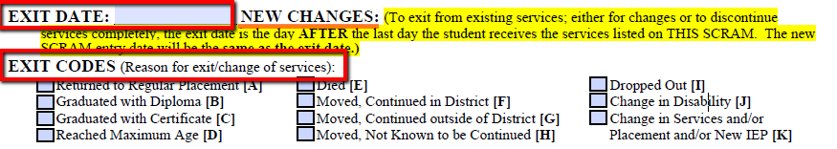
9. Exit Date And Exit Code

Guidelines for Completing the Exit Date and Exit Code
- The Exit Date is the day AFTER the last day the student received the services listed on the SCRAM document.
- Enter an exit date to exit a student from existing services; either for changes or to discontinue services completely.
- The Exit Code is the reason for the exit date (every exit date must have an exit code).

Common Errors for Exit Date and Exit Code:
  - An exit date is listed without an exit code.
  - A student is withdrawn from school, but an exit SCRAM is not submitted.
  - A student is no longer eligible for special education, but an exit SCRAM is not submitted.
  - A blank SCRAM document is submitted with only the student’s name, exit date, and exit code marked.
  - More than one exit code is marked.
  - Errors in exit and entry dates can result in a loss of days counted and loss of funding.

RESOURCES
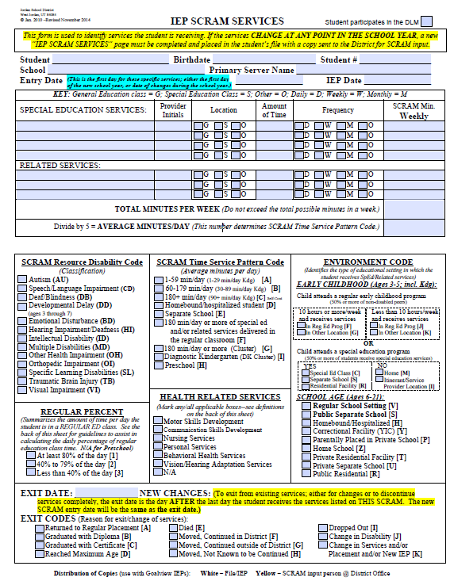
IEP SCRAM Services Document, Revised November 2014 (Page 1 of 2)
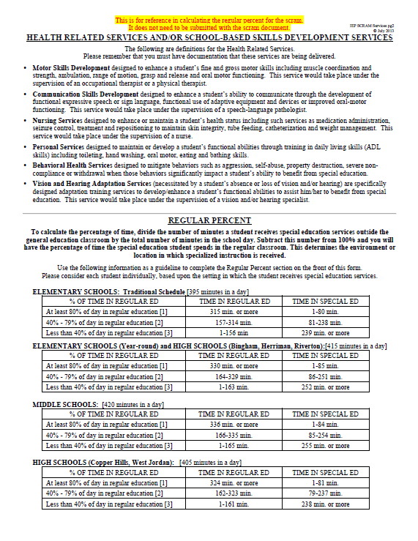
IEP SCRAM Services: Health Related Services and Regular Percent (Page 2 of 2)
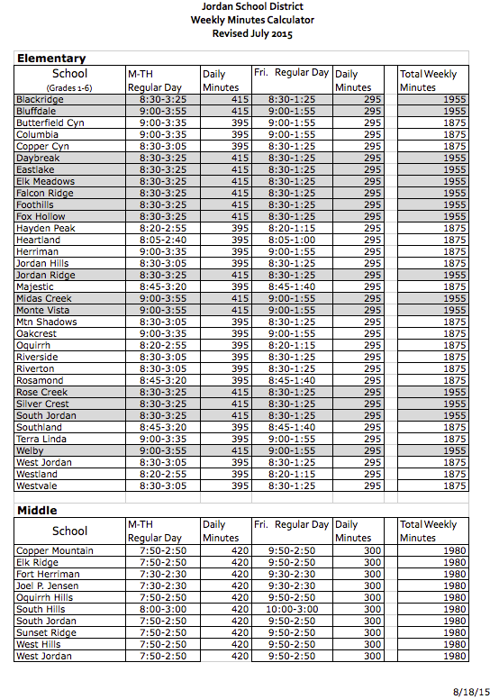
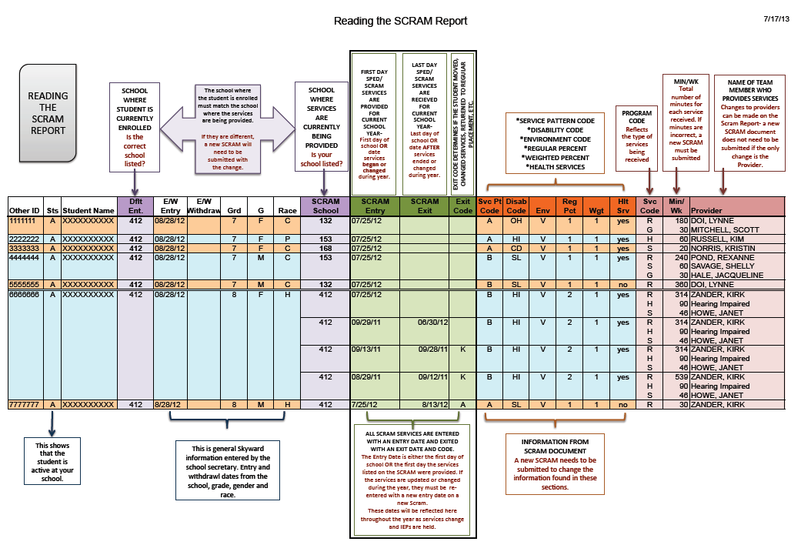
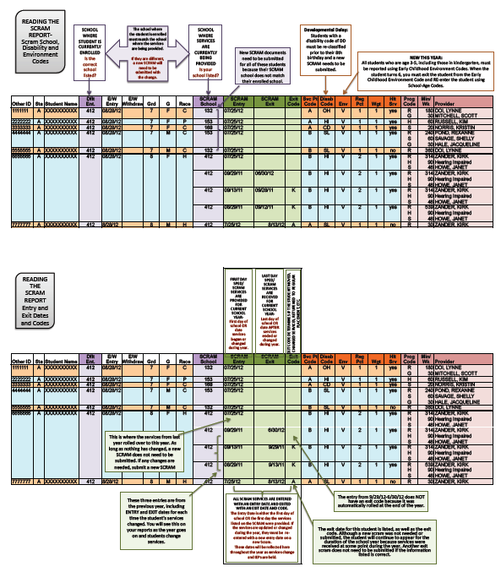
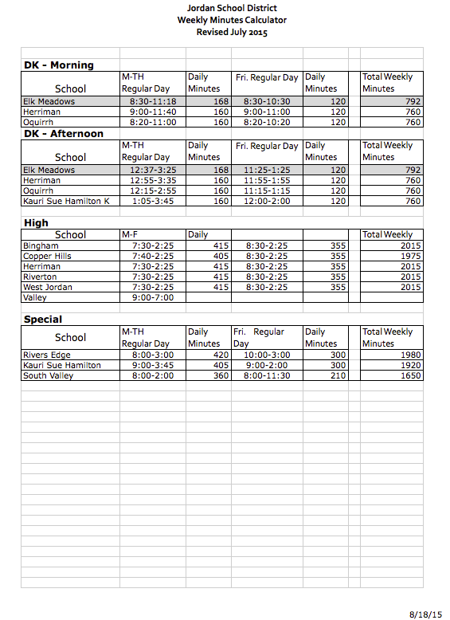
Reading the SCRAM Report (1 of 2)
Reading the SCRAM Report (Page 2 of 2)

