Instructions for completing PNP (Access Profile) and First Contact Survey
(More information found in the Educator Portal User Guide pgs. 31-52
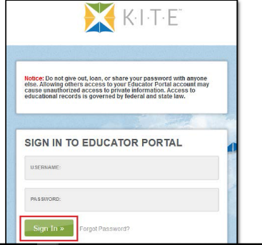
- Log into Educator Portal at: https://educator.cete.us/AART/logIn.htm
Username is your Jordan District email address. You should have received an email from KITE to set your password. If you did not receive this email, please contact Bekkah Friant at 801-567-8112 or bekkah.friant@jordandistrict.org
- If you have not completed the Security Agreement, do that now!
Click My Profile.
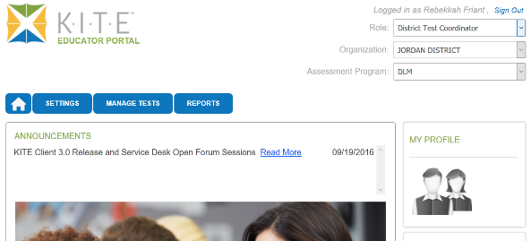

- Click Agree, then click Save
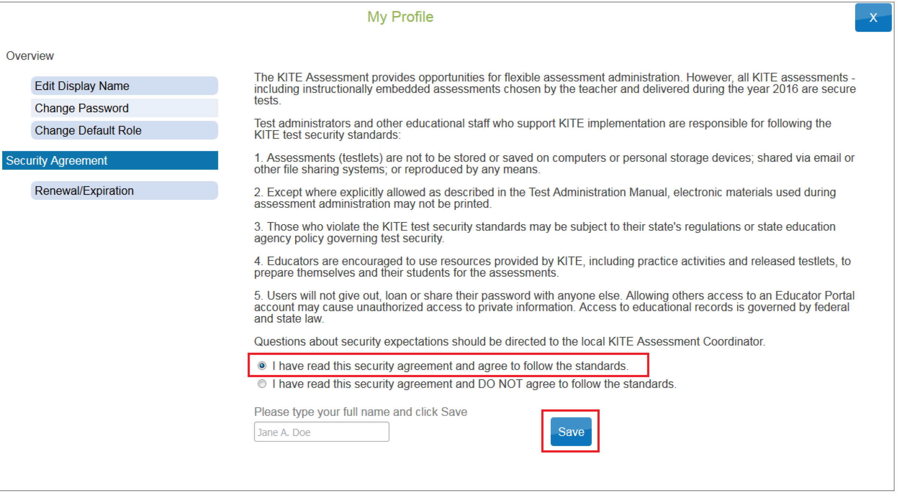

- Click Settings.
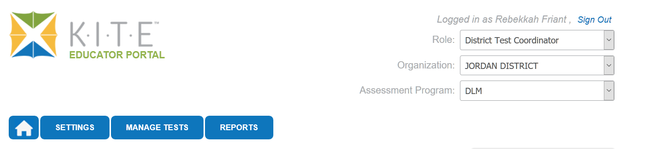

- Click Students.
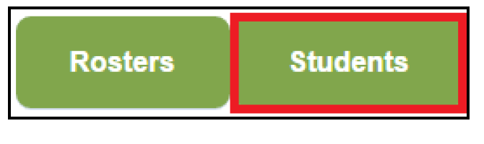
- In the drop down menu, click View Students.

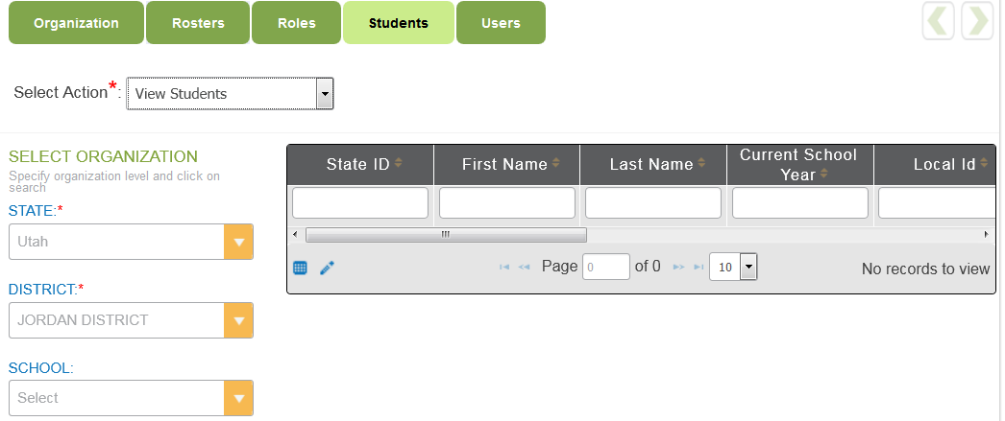
Information under the “SELECT ORGANIZATION” should automatically be filled in with the State, District and School.

- You will see a list of your students. If you are missing any students, please contact Bekkah Friant ASAP. Students are uploaded automatically to the Educator Portal from Skyward. Students are marked as DLM eligible from the SCRAMS that you send in. If you have not sent in SCRAMS indicating that your student qualifies for the DLM, they will not appear.

- You can scroll over from here and to see the ACCESS PROFILE column and the FIRST CONTACT Survey Column.
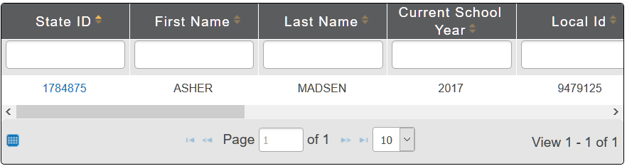

Or you can click blue box and select the columns you would like to see.
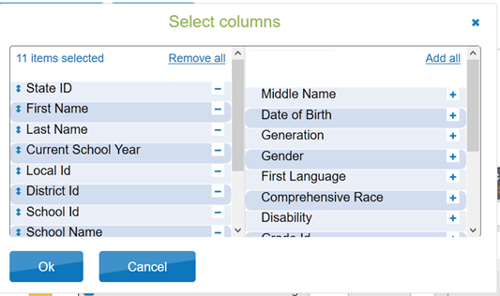

- Next Click on the student’s “State ID”.
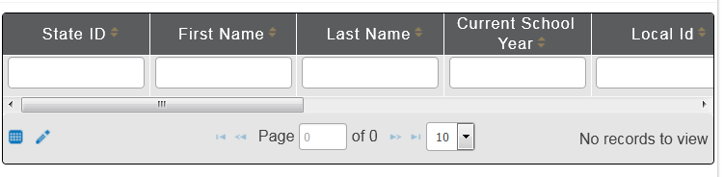

- The “View Student Record” window will appear. Click the link next to Access Profile (PNP).
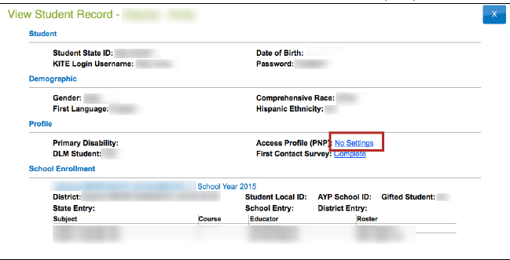
After the PNP is completed, the link will read CUSTOM. If you need to make changes to the student’s PNP, you can still click on the link and edit the PNP.

- The student’s Summary tab of the PNP will appear; Click Edit Settings.
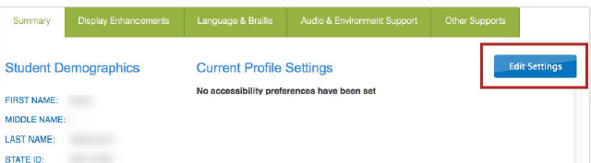

- Click on Display Enhancements and review and select any options needed for the student.
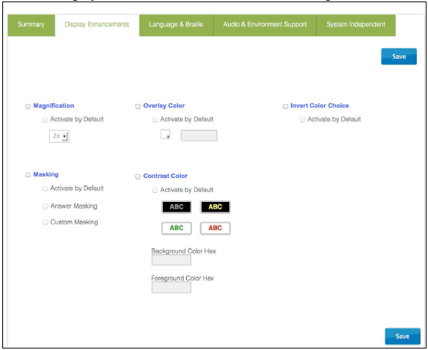

Mark each option needed for student. The following table describes each enhancement option:
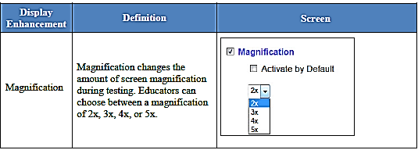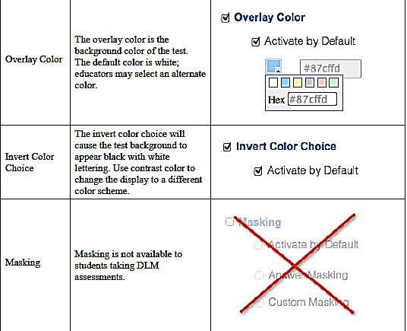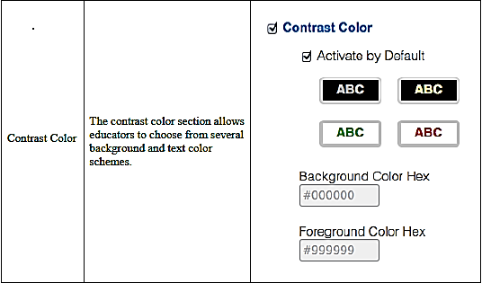

- Click Save and move to next Tab.

- Click Language and Braille.
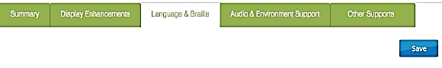
Uncontracted Braille will be the only option available on this screen and it will not be available until the 2016 Spring Operational testing.

- Click Save.

- Click Audio & Environment Support. This is for support related to read aloud and switch use.
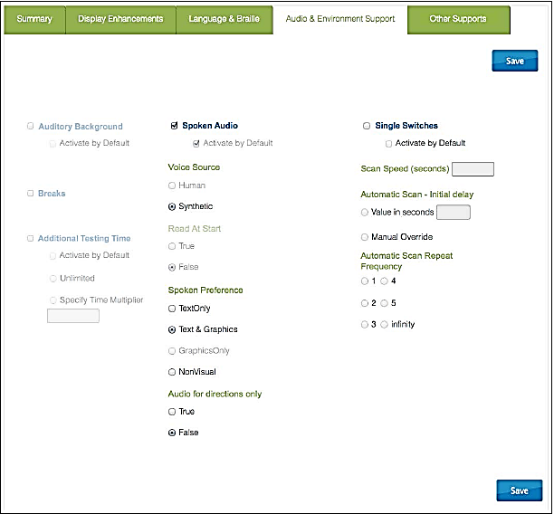

The following tables describe each of the support options:
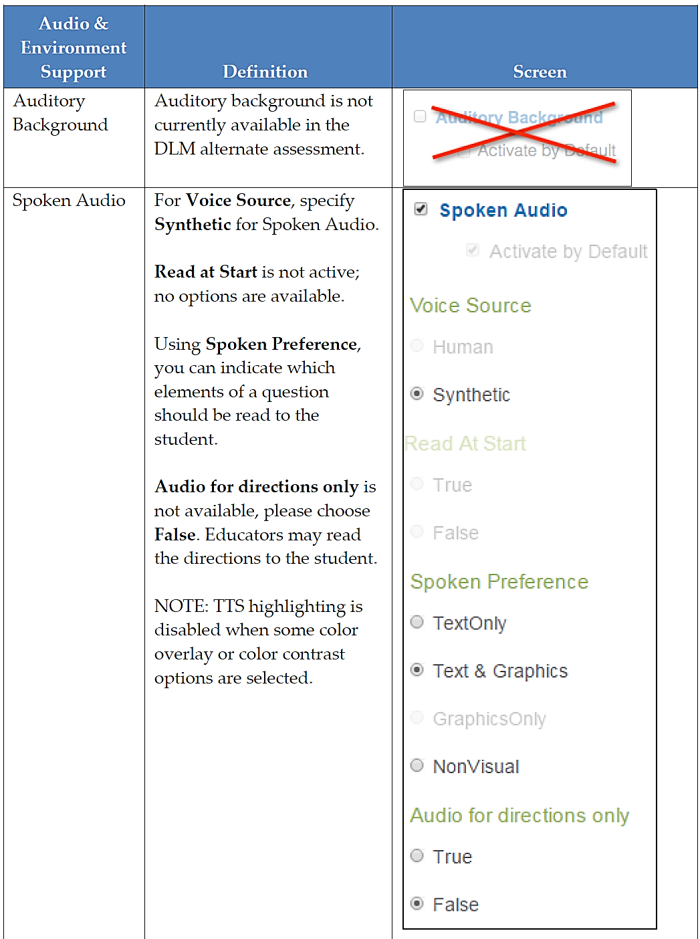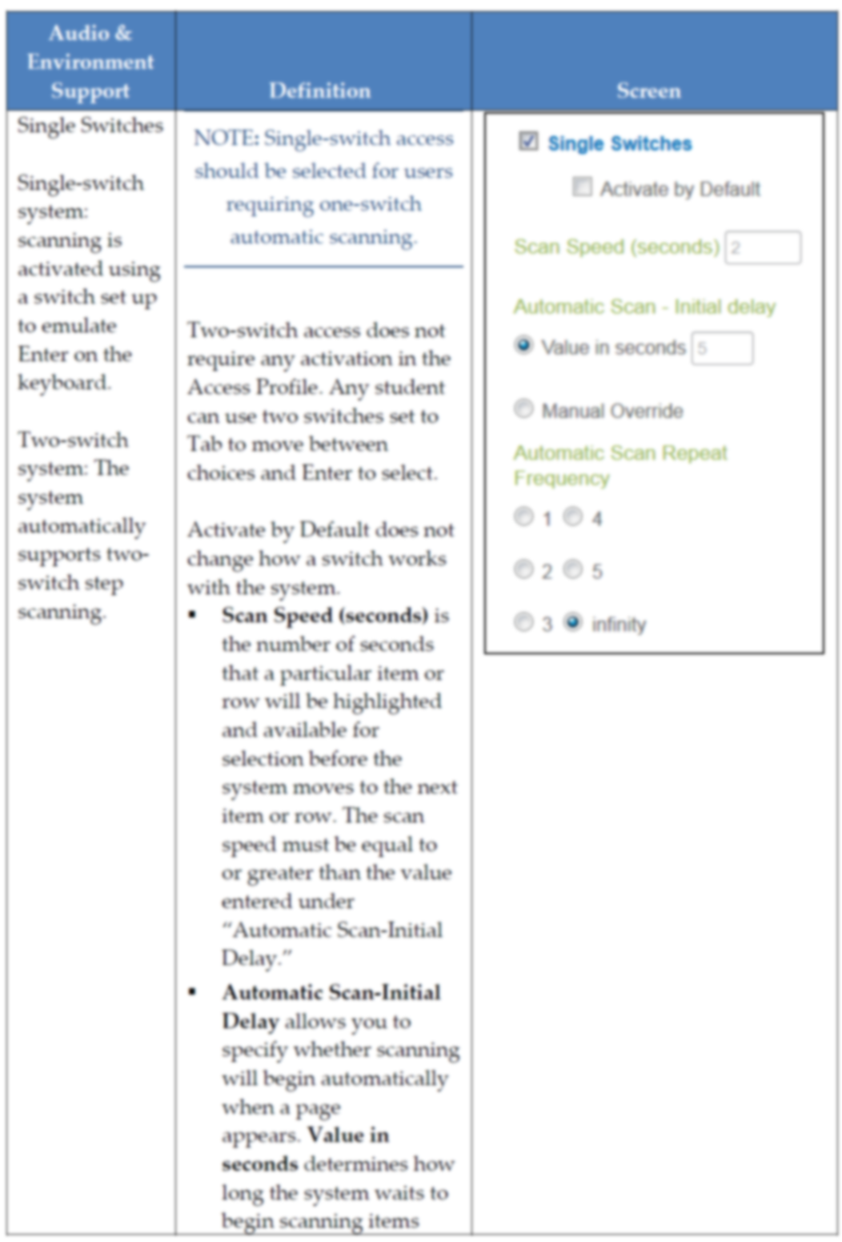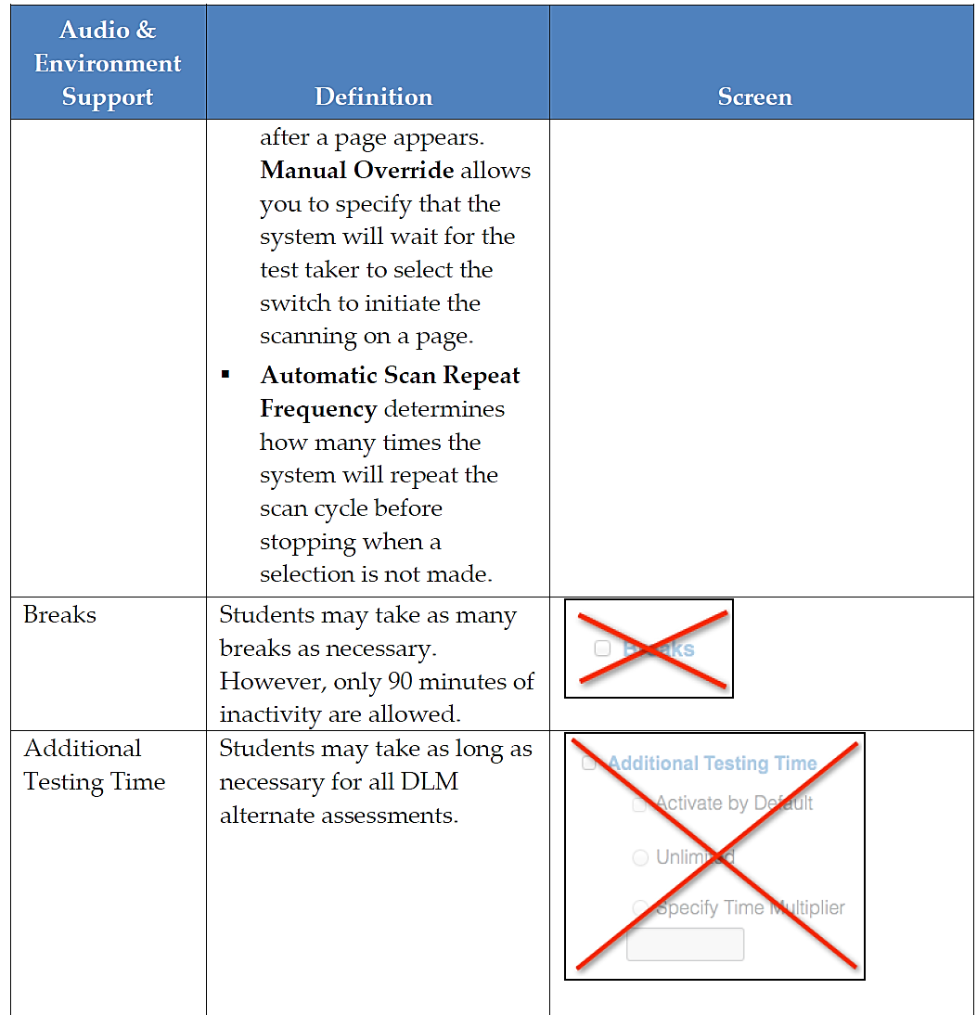

- Click Save.

- Click on Other Supports.
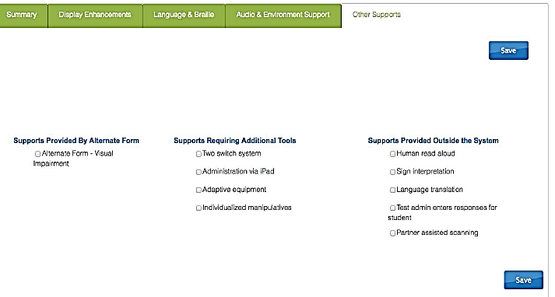

The following table explains the Other Supports available:
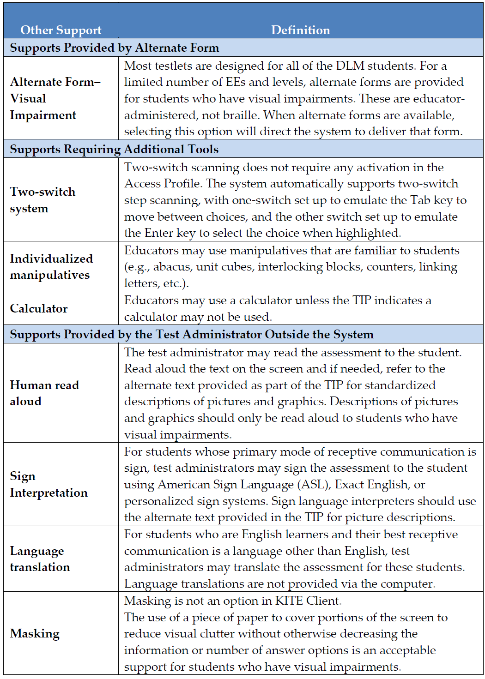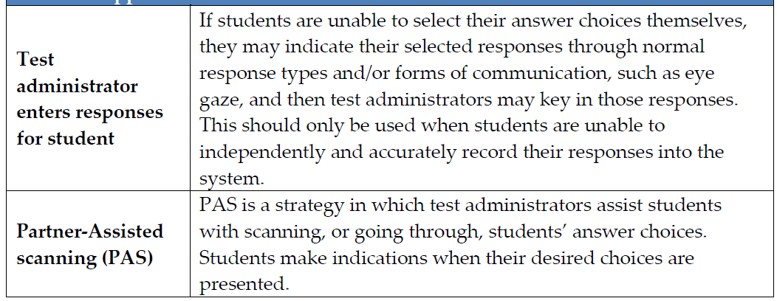

- Click Save.
- After all of the chosen settings have been saved, you will be redirected back to the Summary page. The page will now display all of the options you have marked.
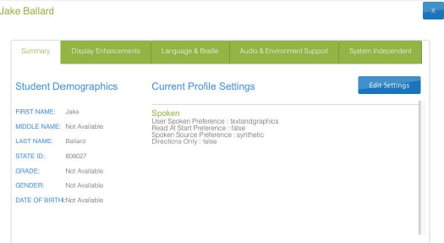

- If you need to make any changes, click on Edit Settings.
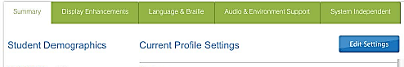

- Click “X” to close the popup window.
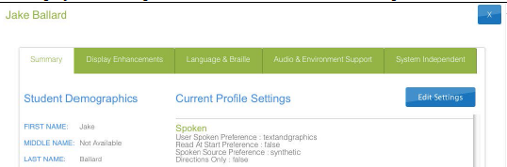

- Follow steps 1-6 to edit/start the student’s First Contact Survey.

- For students who had a First Contact Survey filled out last year, you will still need to go in and edit the survey. The student’s info will show “Ready to Submit”
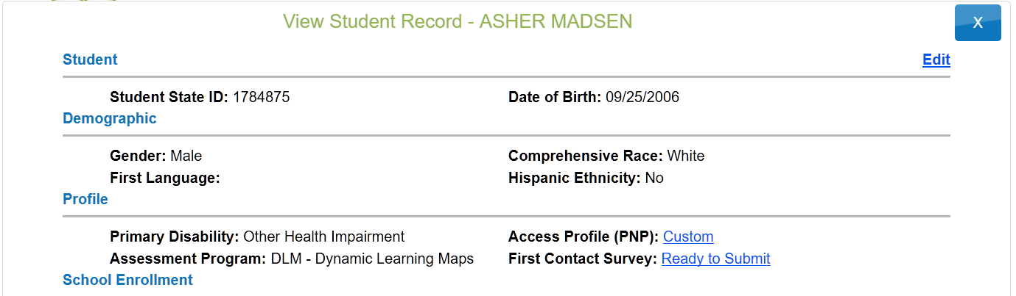

- Click Start Survey (If you are coming back to edit a survey, you will click Edit Survey)
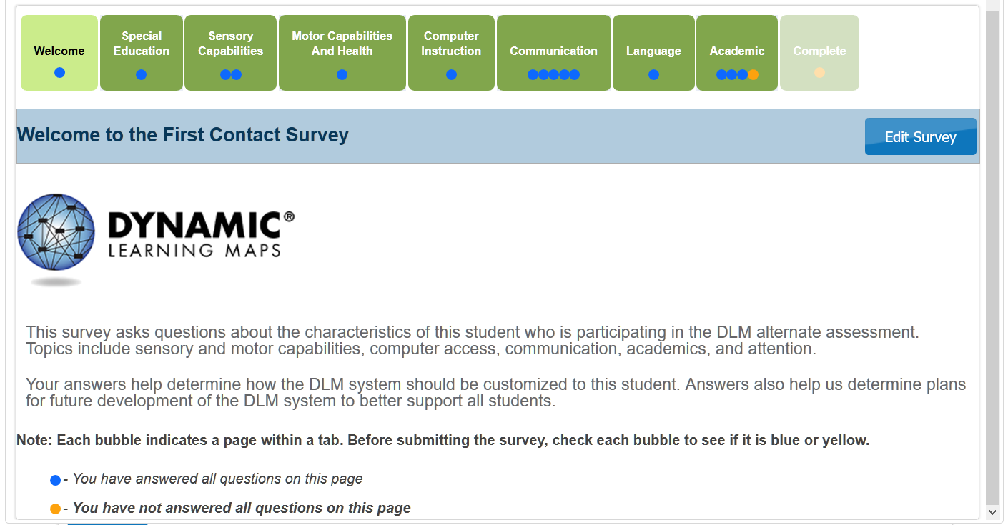

Yellow circles indicate the questions have not been answered under that tab. Blue circles indicate the questions have been answered, but you may still make changes to them.

- Click Special Education
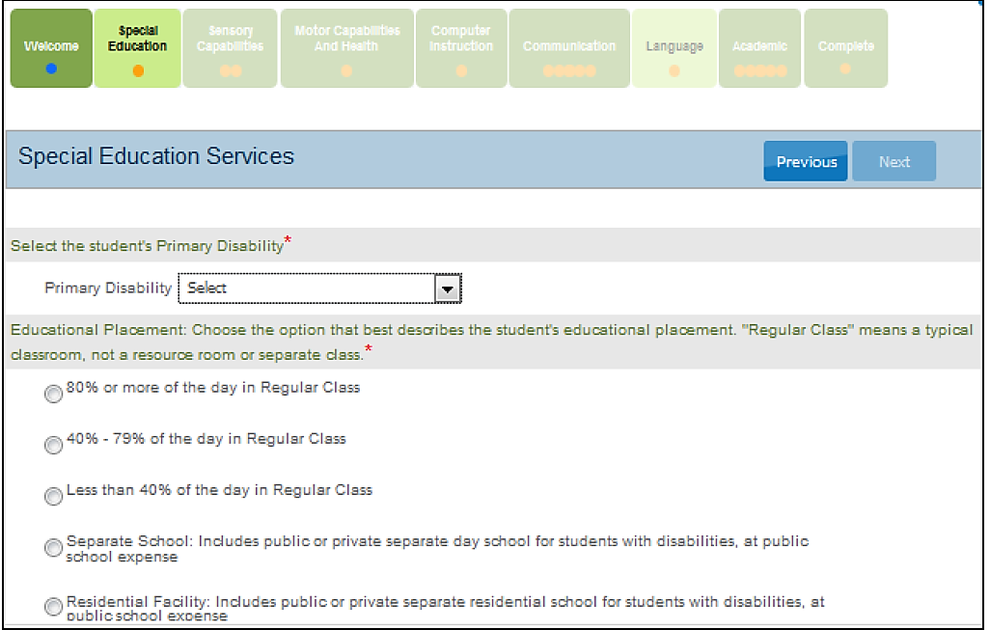
This is where you select the student’s primary disability and by selecting the option that most closely mirrors the student’s current class placement.

- Click Next. (you should now see a blue circle in the Special Education tab)

- Next you will be directed to the Sensory Capabilities tab.
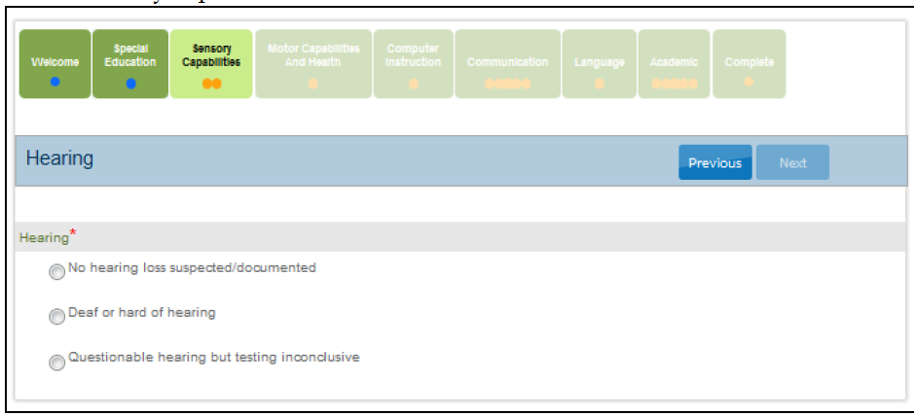
Answer the questions regarding the student’s hearing and vision sensory capabilities. Click Next.

- Motor Capabilities.
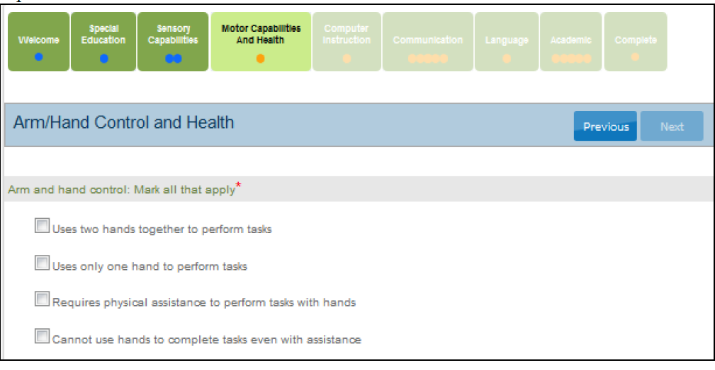
Answer the questions regarding the student’s walking, mobility support, arm and hand control, and head control.
Click Next.

- Computer Access tab is next. Under this tab, you will fill out the student’s ability to use a computer.
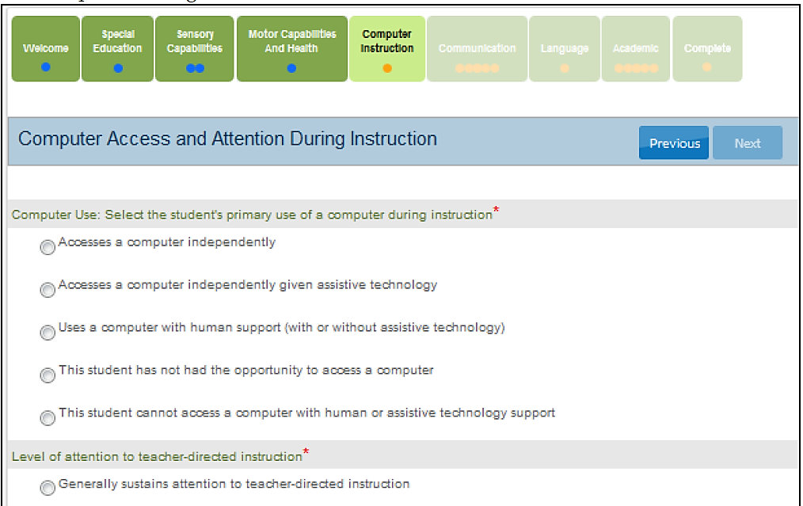
Click Next.

- Communications tab is next. Under this tab, you will be answer questions on the student’s expressive and receptive abilities and needs. (Note some tabs will have multiple circles; please make sure that all of the circles turn blue. If they are not, you have missed a question under that tab.)
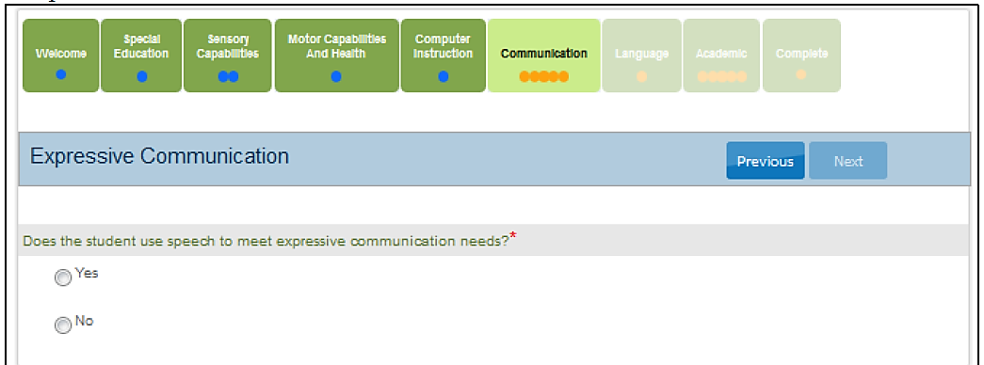
Click Next.

- Language tab. Under this tab you will answer questions about the students’ primary language
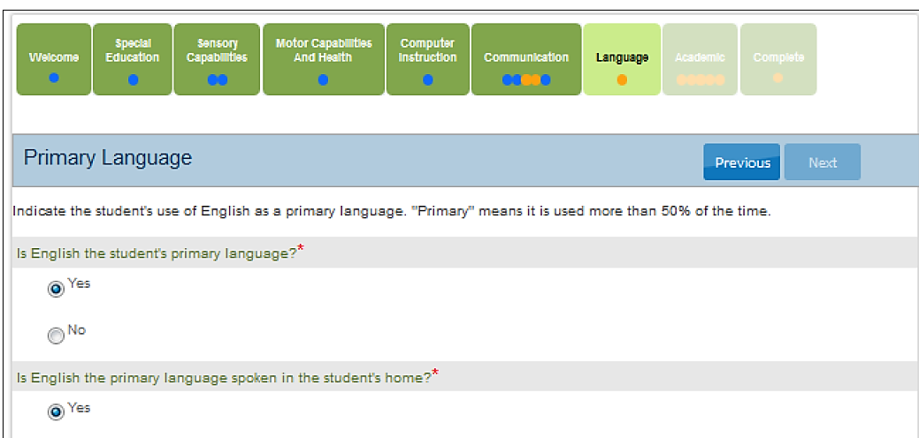
Click Next.

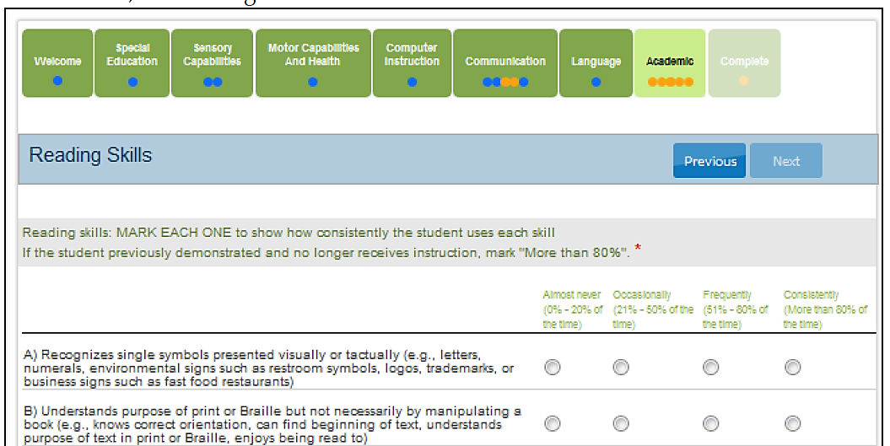
- You will be directed to the Academics tab. Under this tab, you will answer questions on the student’s skills in reading, math, and writing. If you are unsure what to mark, you can always mark one below, what you think. The DLM questions are adaptive; the questions will get harder or easier as the student answers them.

Click Next.

- You will be directed to the Complete tab. Click Submit Survey.
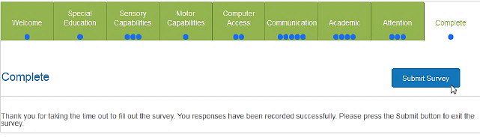
Check again, to make sure that all of the circles are blue under each tab. If you see any that are yellow, go back and check those tabs again and answer the questions missed.

- After completing the Survey, check the Student List and make sure that the First Contact link read’s “Complete”. (If you need to make any changes to the First Contact survey, click on Complete).
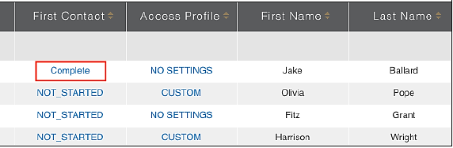

If a student does not have the First Contact Survey completed, the system will not generate a test for that student. If you fill out the First Contact Survey after the testing window has opened, it will take 24 hours for a test to be assigned to the student.

If you have any questions regarding the PNP (Access Profile) or the First Contact Survey, please contact Bekkah Friant @ 801-567-8112 or bekkah.friant@jordandistrict.org.

